**Word to HTML Converter Tool**

**Word转换HTML网页**

<https://it365.janqi.com/word-to-html/>

The [Word to HTML Converter](https://it365.janqi.com/word-to-html/zh.html) is a powerful online tool that can convert Word DOCX files into HTML web pages. This tool perfectly preserves Word document formatting including fonts, colors, background colors, tables, images, and links.

**Word to HTML Conversion Effect Test**

Below are various formatting examples that demonstrate how well the converter handles different Word elements:

***Font and Color Examples***

This is **highlighted text** with yellow background.

This is **red colored text** for emphasis.

This is blue colored text in larger font size.

***Background Color Example***

This paragraph has a green background color with white text, perfect for highlighting important information.

***Table Example***

| **Feature** | **Supported** | **Quality** |
| --- | --- | --- |
| Fonts | ✓ Yes | Excellent |
| Colors | ✓ Yes | Perfect |
| Tables | ✓ Yes | Great |
| Images | ✓ Yes | High Quality |

***Image Example***

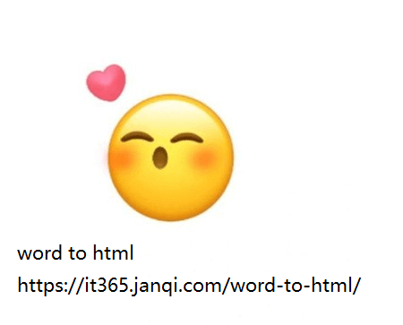

***Heading Examples***

**Main Title (H1)**

**Section Title (H2)**

***Subsection Title (H3)***

***Body Text Example***

This is regular body text that demonstrates how normal paragraphs are converted from Word to HTML. The converter maintains proper spacing, line breaks, and text flow to ensure your content looks professional in web format.

Links are also preserved: Visit [Word to HTML Converter](https://it365.janqi.com/word-to-html/zh.html) for more information.

**中文版本 Chinese Version**

**Word转HTML网页转换工具**

<https://it365.janqi.com/word-to-html/>

[Word转HTML转换工具](https://it365.janqi.com/word-to-html/zh.html)是一个强大的在线工具，能够将Word DOCX文件转换为HTML网页文件。该工具完美保留Word文档的格式，包括字体、颜色、背景色、表格、图片和链接。

**Word转换HTML效果测试**

以下是各种格式示例，展示了转换器如何处理不同的Word元素：

***字体和颜色示例***

这是**高亮显示的文本**，带有黄色背景。

这是**红色文本**，用于强调。

这是蓝色文本，字体更大。

***背景色示例***

这个段落有绿色背景和白色文字，非常适合突出重要信息。

***表格示例***

| **功能** | **支持情况** | **质量** |
| --- | --- | --- |
| 字体 | ✓ 支持 | 优秀 |
| 颜色 | ✓ 支持 | 完美 |
| 表格 | ✓ 支持 | 很好 |
| 图片 | ✓ 支持 | 高质量 |

**主标题 (H1)**

**章节标题 (H2)**

***小节标题 (H3)***

***正文示例***

这是常规正文文本，展示了普通段落如何从Word转换为HTML。转换器保持适当的间距、换行和文本流，确保您的内容在网页格式中看起来专业。

链接也会被保留：访问[Word转HTML转换器](https://it365.janqi.com/word-to-html/zh.html)了解更多信息。

更多实用工具请访问：[**IT365工具箱 - https://it365.janqi.com**](https://it365.janqi.com)